**Decision Statement Exercises**

Use PyScripter to write all of the following programs. Ensure that you save your completed programs to the appropriate folder.

1. Write a program that asks the user for their numeric grade. Your program should print “Congratulations” if they passed (the mark is at least 50), and “Nice try” otherwise. **(Decision1)**
2. Write a program that asks the user for their numeric grade and outputs the corresponding letter grade. You can use the following chart to assist you. **(Decision2)**

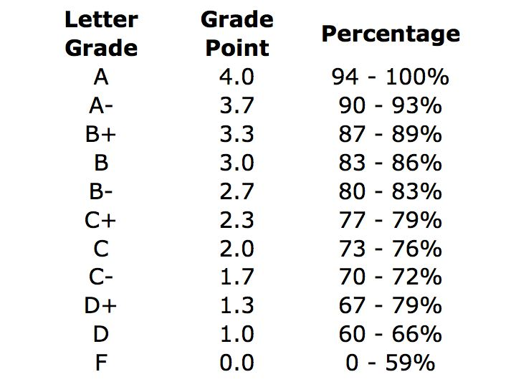

1. Your body mass index (BMI) is calculated by taking your weight in kilograms and dividing by your height in meters squared. For example, if your weight is 75kg and your height is 1.83m (that is, 183 cm), the calculation would be as follows:

75 ÷ (1.832) = 22.4

The BMI can be categorized as follows:

|  |  |
| --- | --- |
| **BMI** | **Category** |
| Below 18.5 | Underweight |
| Between 18.5 and 24.9 | Normal Weight |
| Between 25 and 29.9 | Overweight |
| 30 or greater | Obesity |

Write a program that asks the user for their weight in kilograms and height in meters. Your program will then compute their BMI and output their corresponding category. **(Decision3)**